Open App Store



Open your Android device and tap the **Play Store** icon.

Search for App

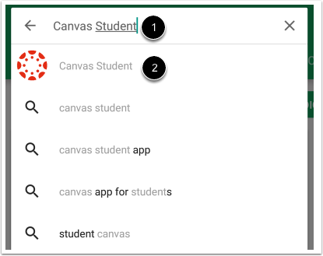

In the search field, type Canvas Student [1]. Tap the full name when it appears [2].

Install App

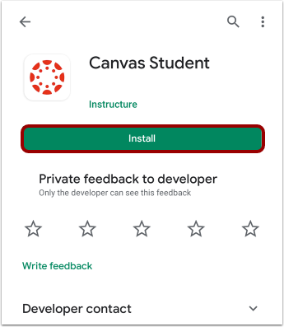

Tap the **Install**button.

Download App

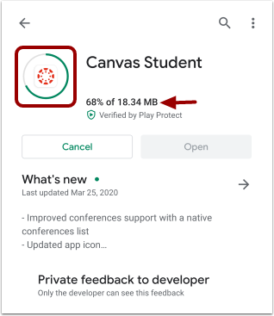

View the app download and install progress.

Open App

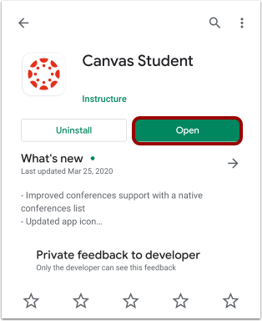

When the app has downloaded and installed onto your device, you can access the app immediately by tapping the **Open**button.

View App on Android Home Screen

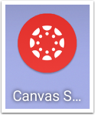

You can also open the app on your Android home screen by tapping the **Canvas Student**icon.